**ABSTRACT**

|  |  |  |  |
| --- | --- | --- | --- |
| **Title** | : | Fitness Gym Membership, Trainer Scheduling, and Payment System with RFID Implementation | |
| **Researchers** | : | Cadena, John Homer A.  Casadores, Danielle Nicole J.  Doronila, John Carlo S.  Oreta, Vince Miguel D.  Pabustan, Rafhael B. |  |
|  |  |  |  |
|  |  |  |  |
| **Adviser** | : | Elias Austria |  |

The project consists of three (3) integrated subsystems, namely the Membership subsystem, trainer scheduling, and the payment system. The membership subsystem is made to allow the end-users to register and access all the features available for users. On the user side of the system, the user will be able to view the gym’s calendar for scheduled events and their registered classes, their own profile, the list of available and joined classes and events, and the trainers of the gym. The user profile is where they can see their information such as their membership types, trainers, and membership dates and expiry. This is also where they can edit their personal information and account details. The rest of the pages are the classes, events, and trainer pages, where the user can view the details of such and register or choose a personal trainer to assist them on their workouts. The second subsystem is the trainer scheduling where both the users and trainers can set their most suitable time for their workout sessions. Once both parties have agreed on matching schedules, the user can then confirm to set their session. The last subsystem is the payment system, which is used for assisting the gym by generating queries and reports and also the user by providing them with official receipts made for their transactions.

The proponents gathered data for the project from interviews, gym goers, internet materials, and other sources. Interviews with the client were held at the very beginning of the development. This was where the initial information were gathered, such as the business processes and business rules; even though Mr. Carlo Cheng, the owner of the fitness gym and our client, did not give much information as to how their gym works around, but instead, he mostly gave only the features that he wants in the system. The team also had presentations to different sets of panels from which we got a lot of details and processes from. Ranging from former students, professors, professionals, gym goers, to all of them combined, suggestions and ideas from the panels were taken and were implemented into the system. Business rules were taken into consideration to aid with the development. A fishbone diagram was also used to help identify the main problems of the business. Other methodologies were also used such as the requirements-features matrix, use case diagrams, use case reports, and activity diagrams.

**(Paragraph 3 – Brief Discussion of Chapter 5)**

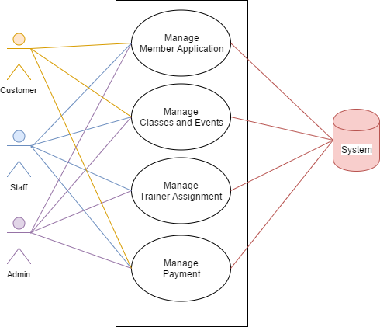**System Use-Case:**